**HOSTING WEBSITE USING USER DATA**

1. Click **Create bucket** 🡪 **General-Purpose**

A **general-purpose S3 bucket** is typically used for storing files, images, backups, logs, or application data. It uses the **S3 Standard** storage class by default, providing high durability, availability, and low latency.

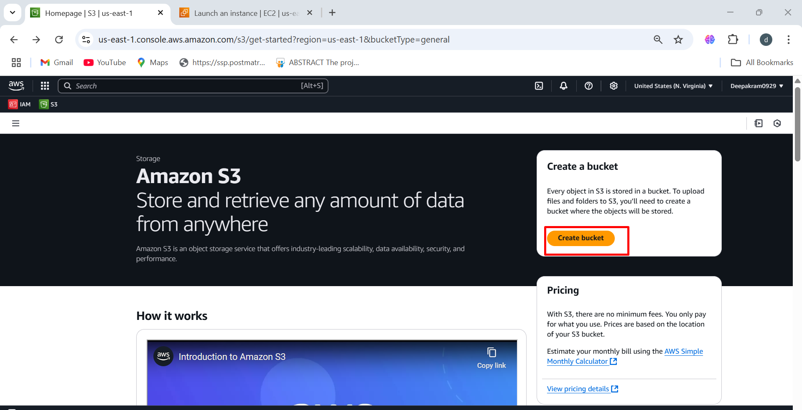

1. Enter a **unique bucket name**

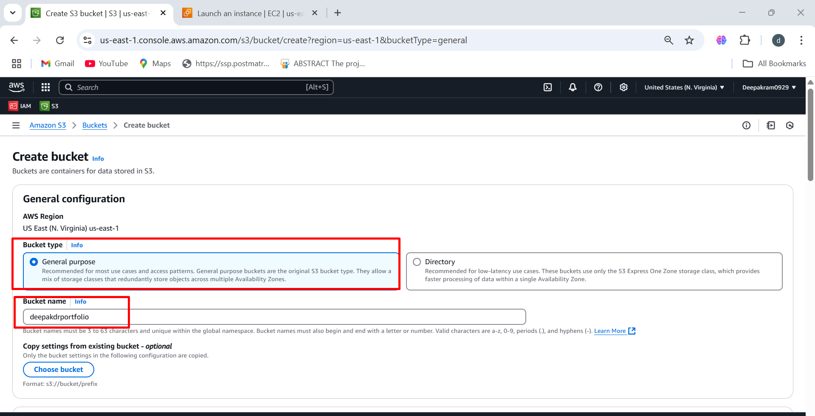

1. Deepakdrportfolio bucket as been created successfully

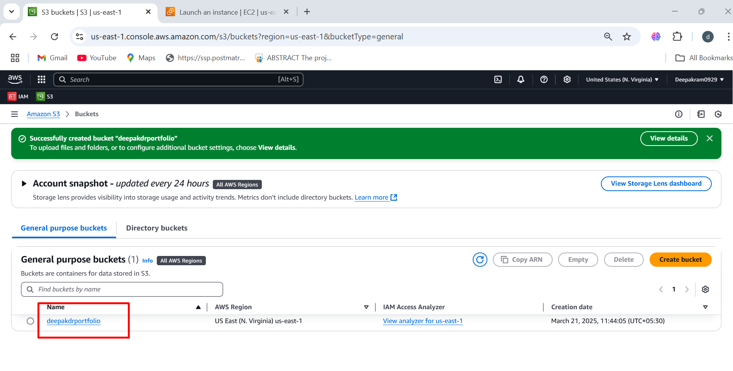

1. No Objects Present, The bucket is empty (no files uploaded yet) 🡪 Clicking **"Upload"** allows you to add files or folders to the S3 bucket.

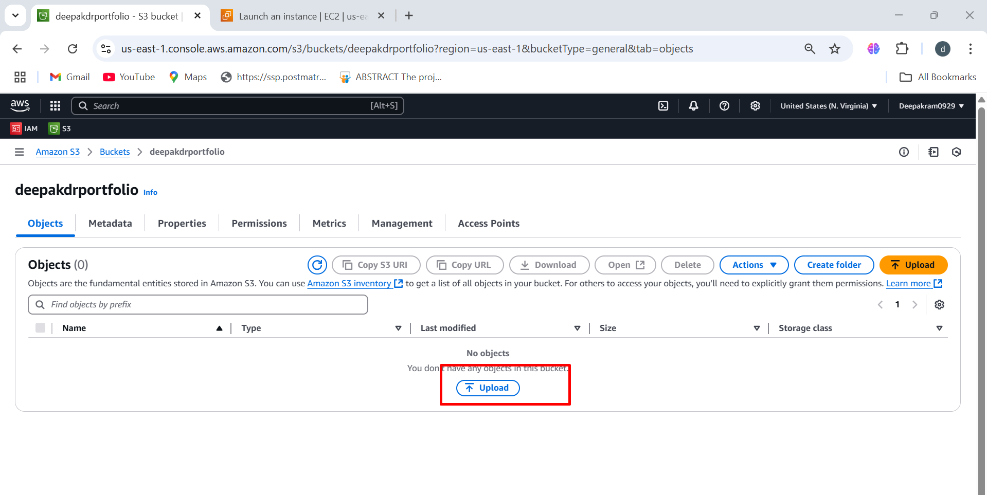

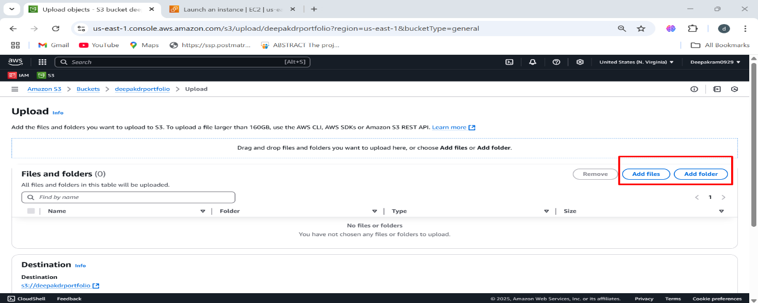

1. After adding files or folder click on upload

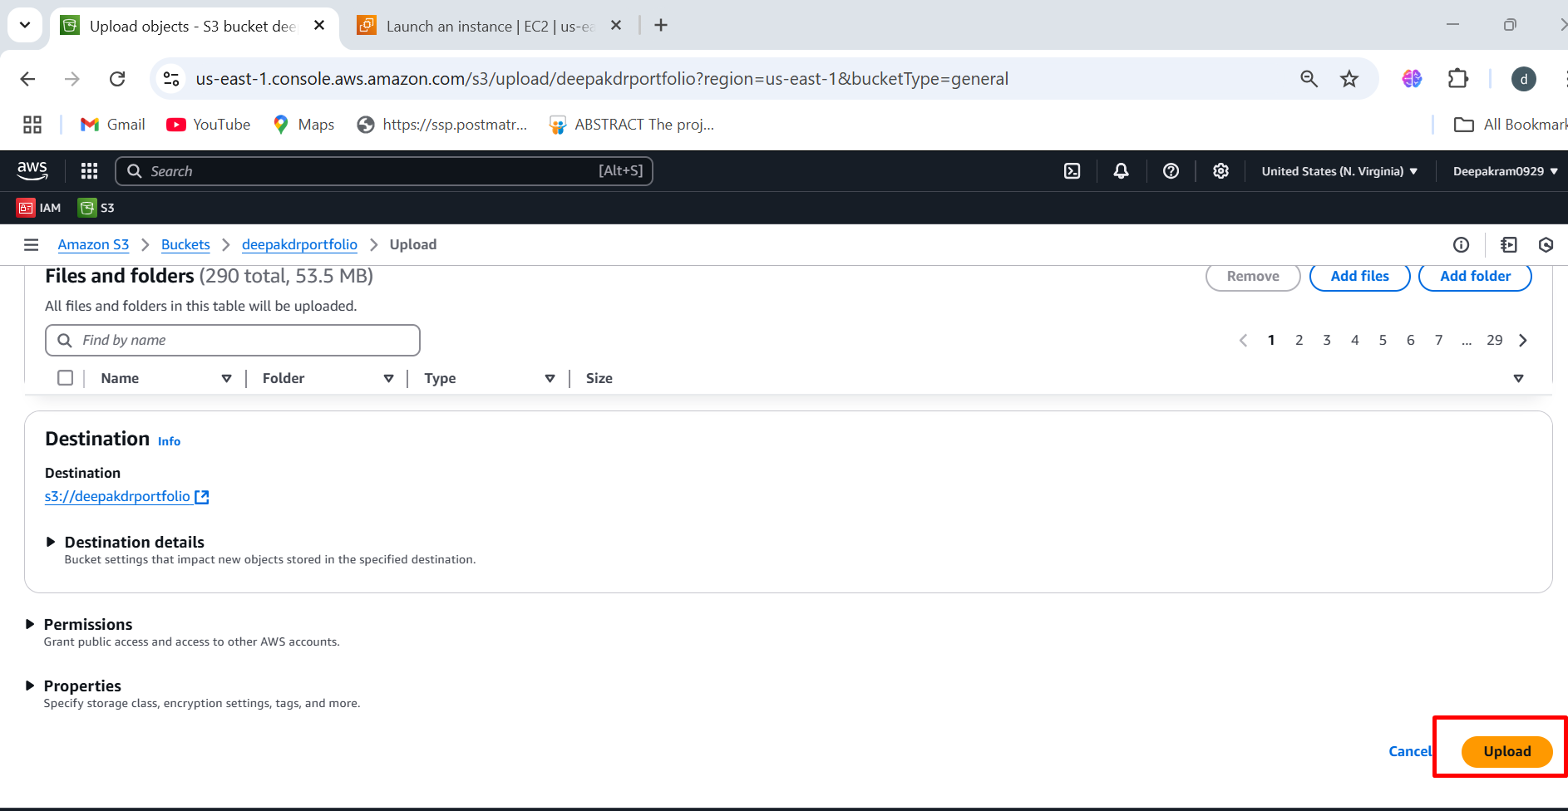

1. File as been uploading as shown in below figure

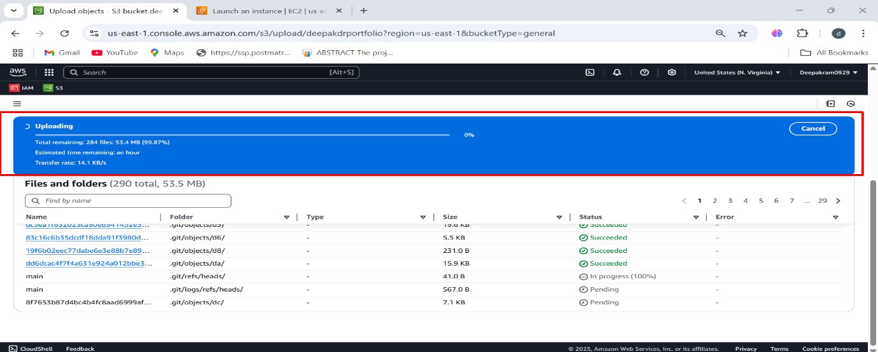

1. We can see the uploaded files in the bucket

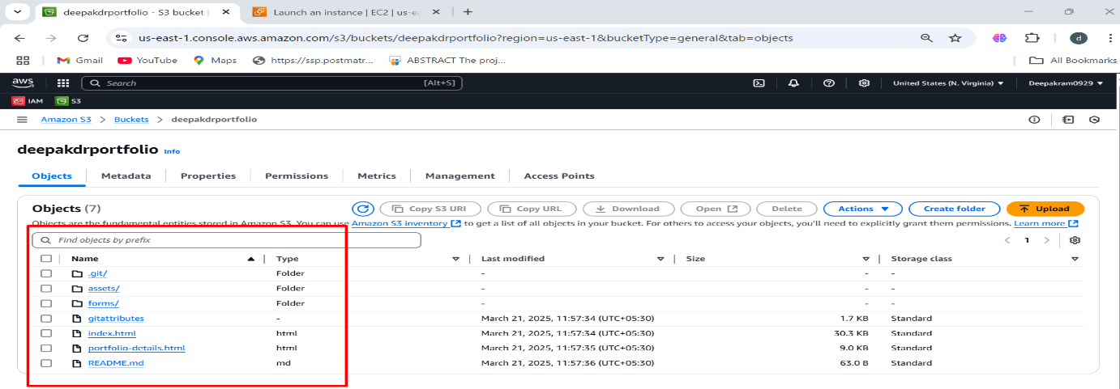

1. Launch the ec2 instances with Name, AMI Amazon linux 2023 🡪 select the Architecture

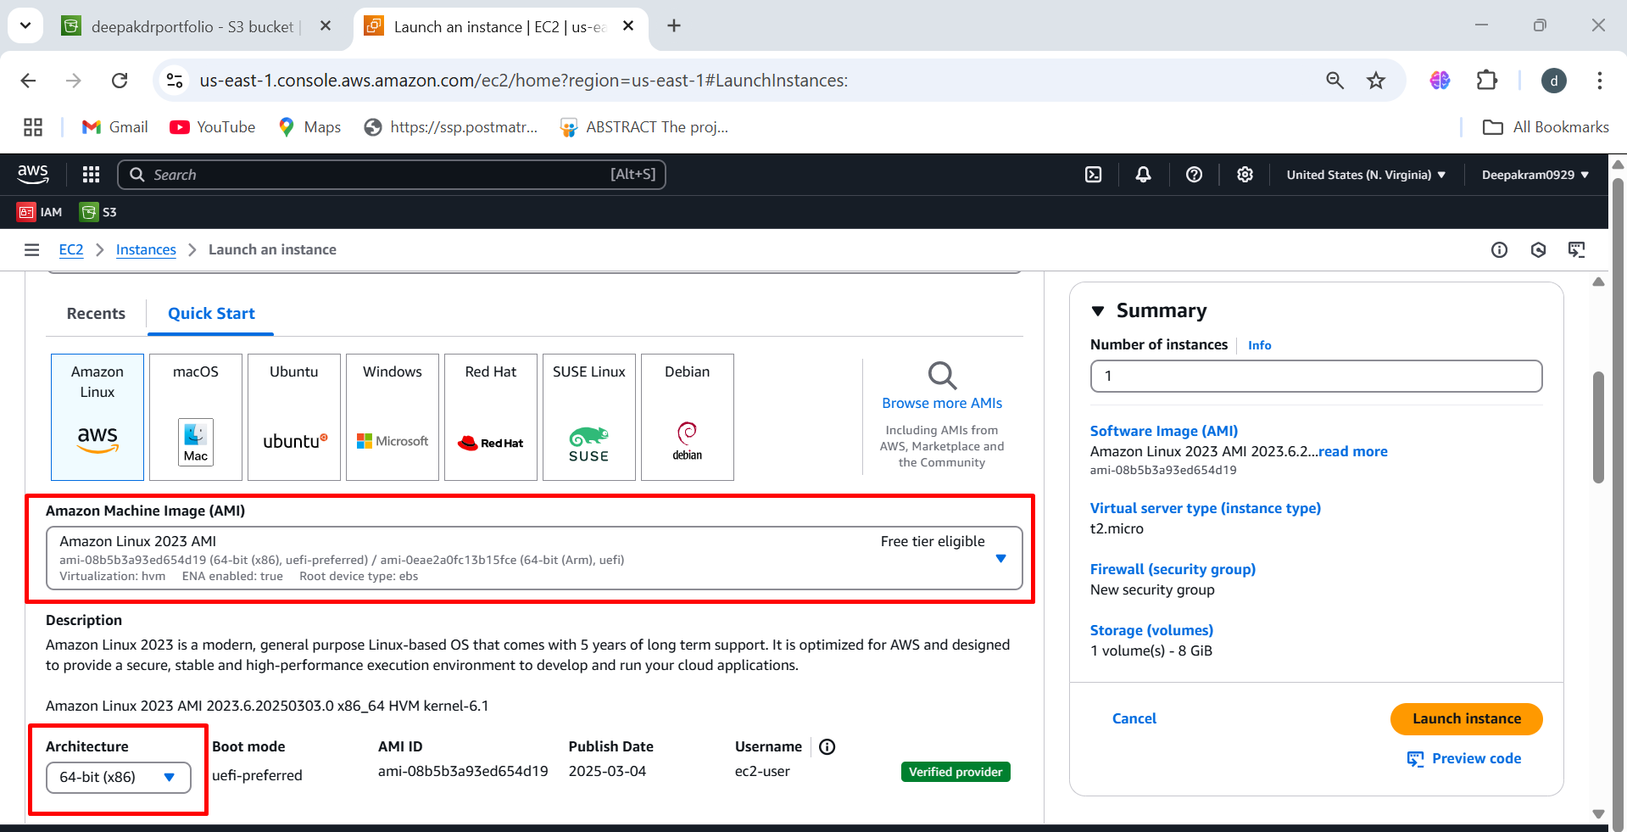

1. Select the instance types 🡪 t2.micro

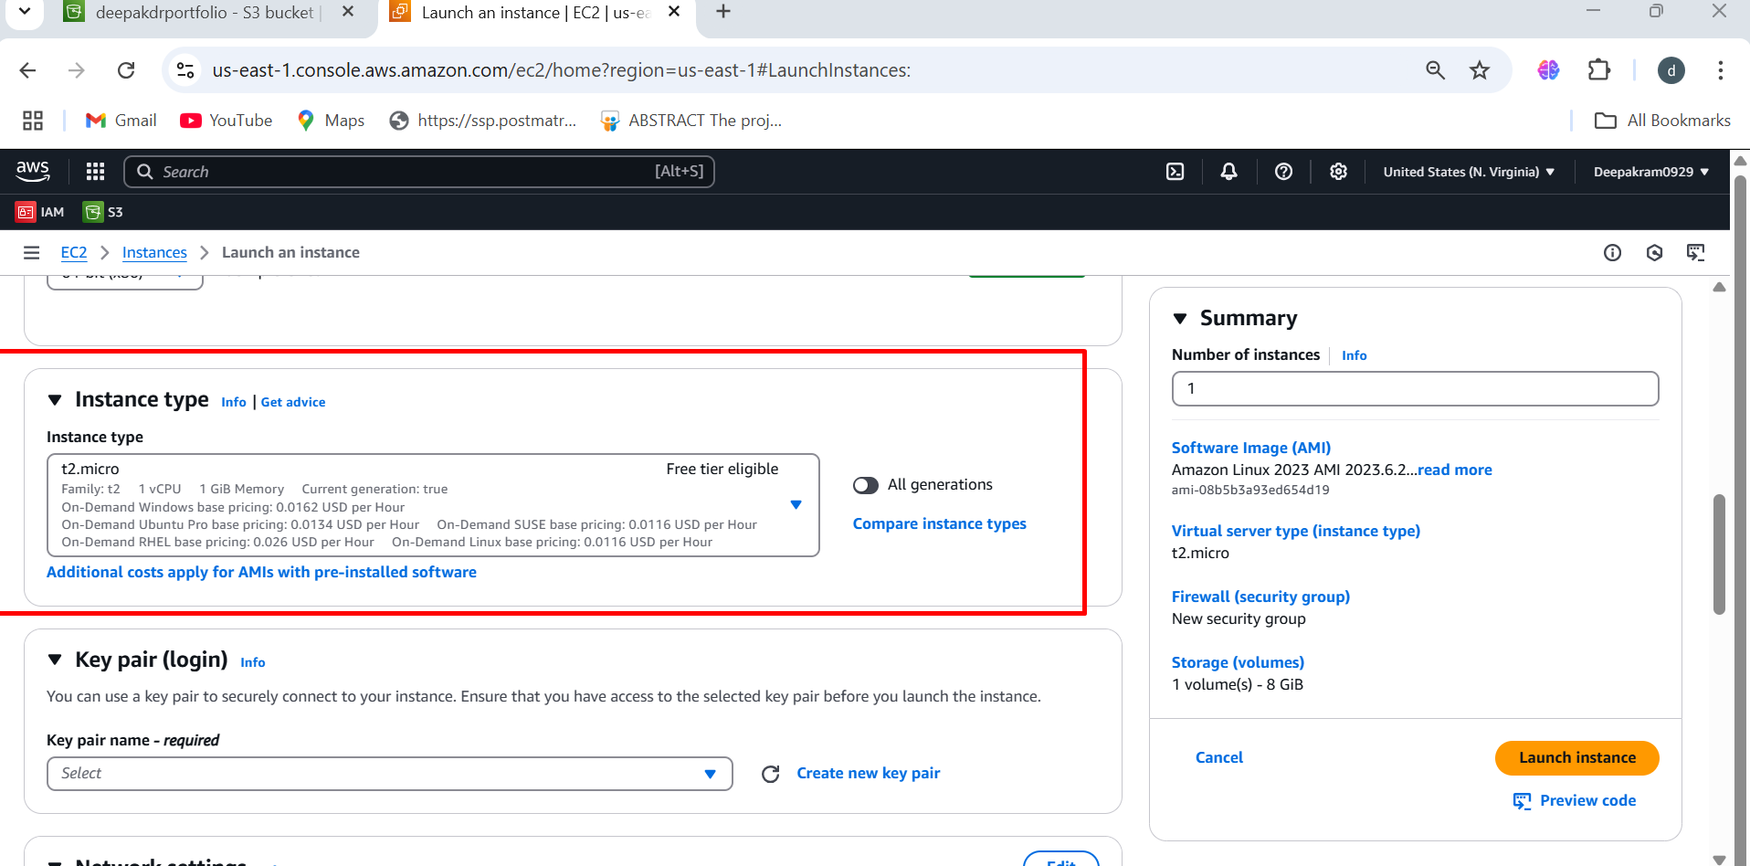

1. Provide the key name

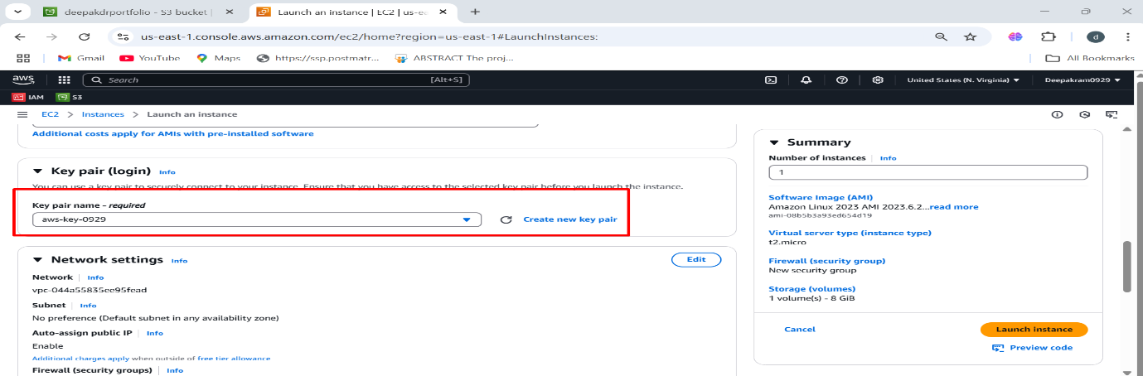

1. Under the network setting 🡪 select the existing security group 🡪 web-ssh-security

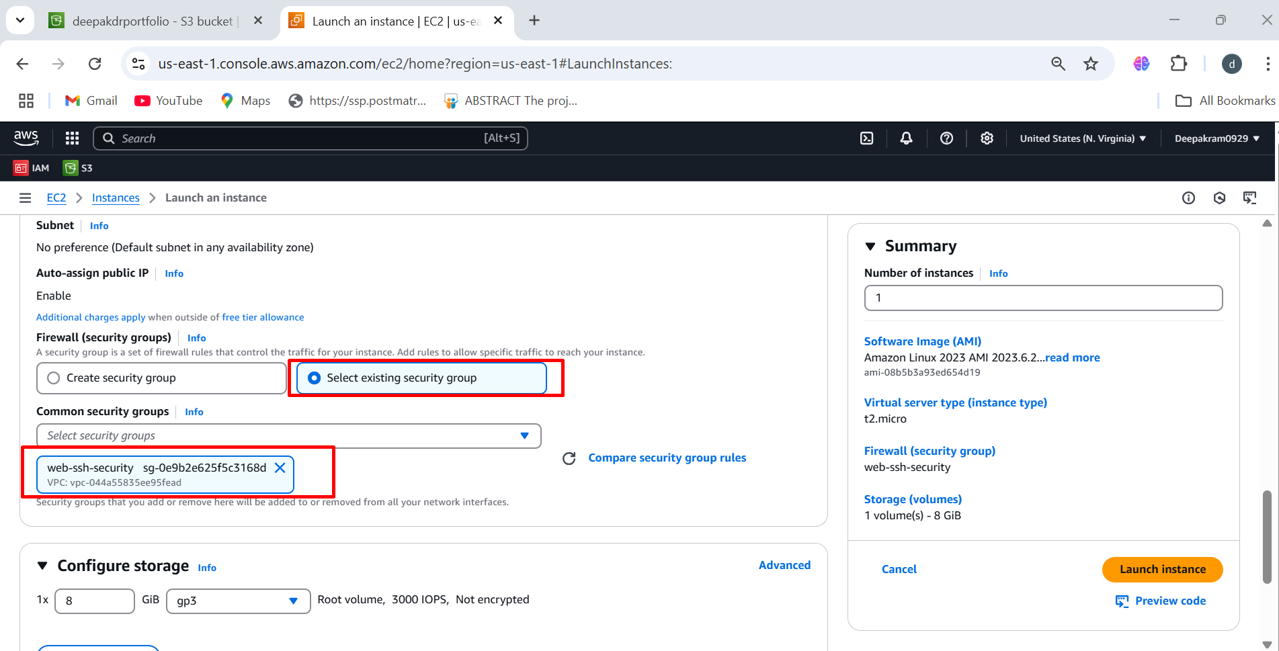

1. Select the storage

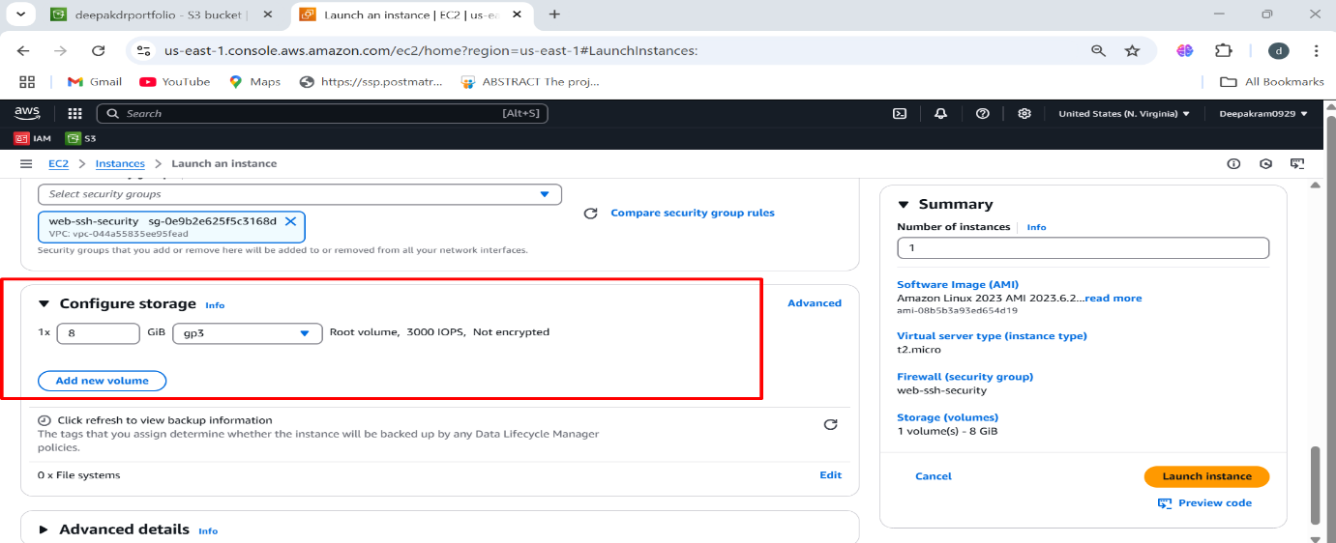

1. Under advanced details 🡪 add IAM

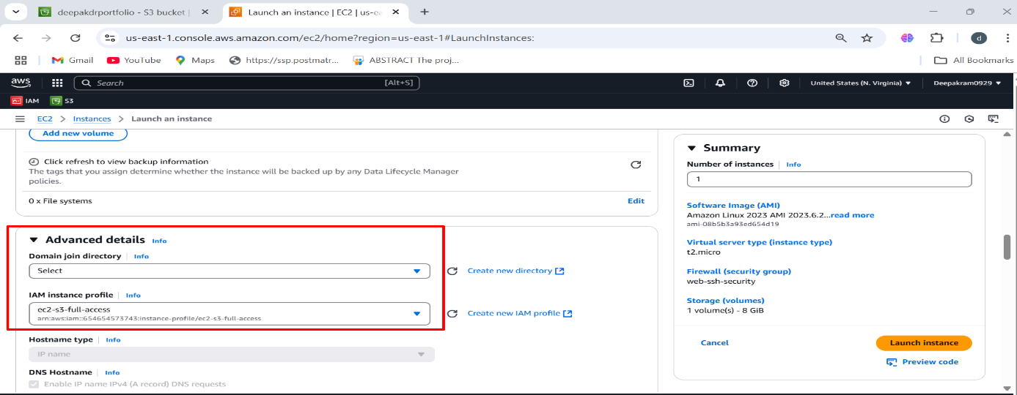

1. Upload or write user data 🡪 shebang

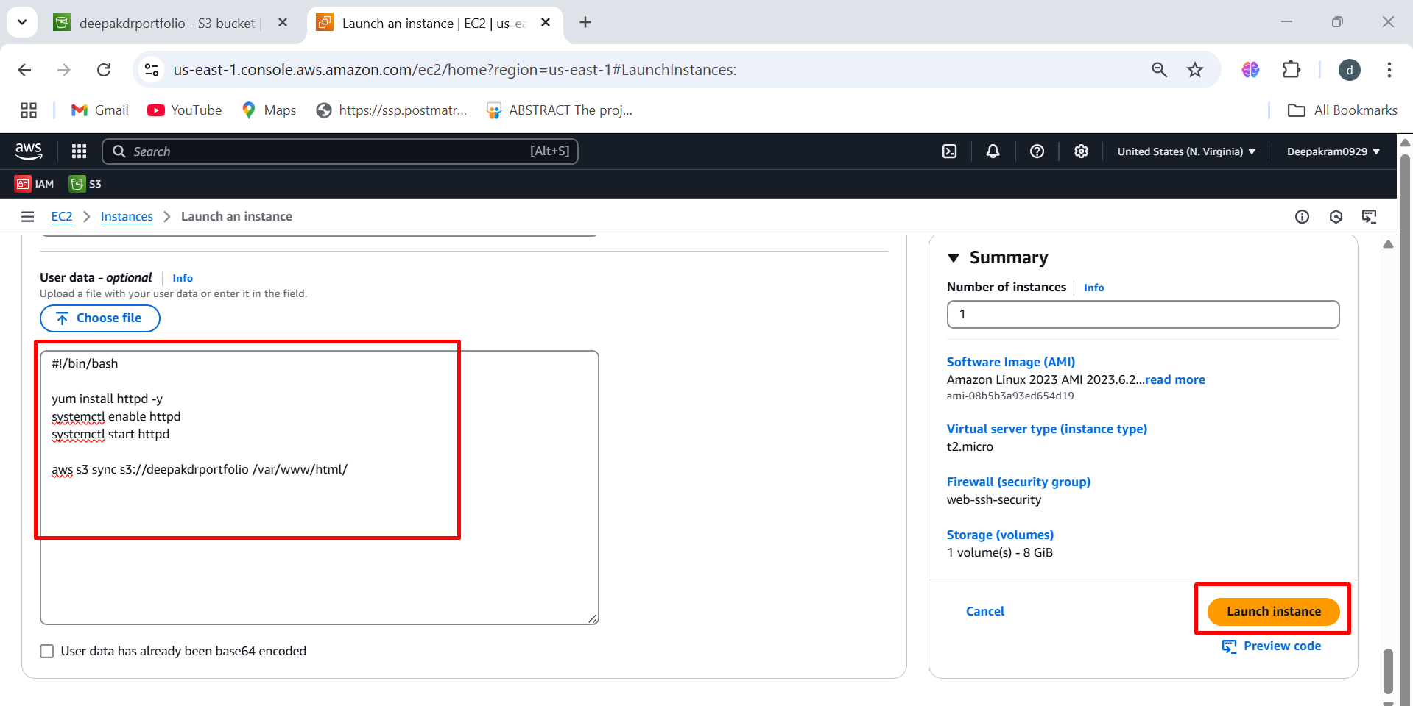

1. Paste the Public IP of the ec2 instances 🡪 output of the portfolio



**HOSTING WEBSITE MANAULLY**

1. Follow the same steps to launch ec2 instances after launching the instances

Select the instances 🡪 action 🡪 security 🡪 modify IAM role 🡪 select the IAM role 🡪 update the role

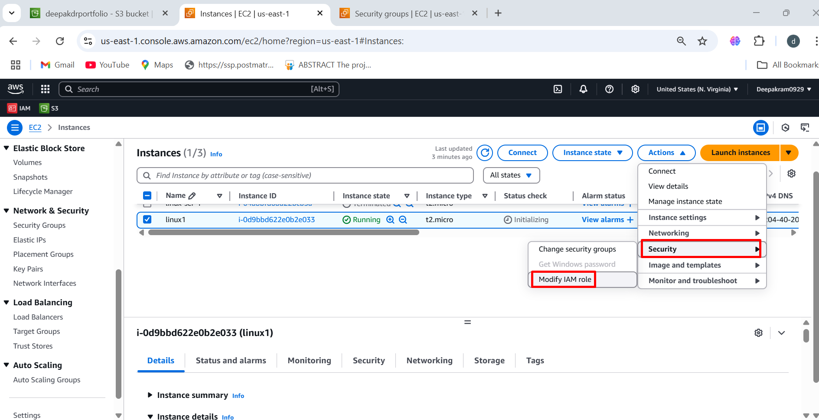

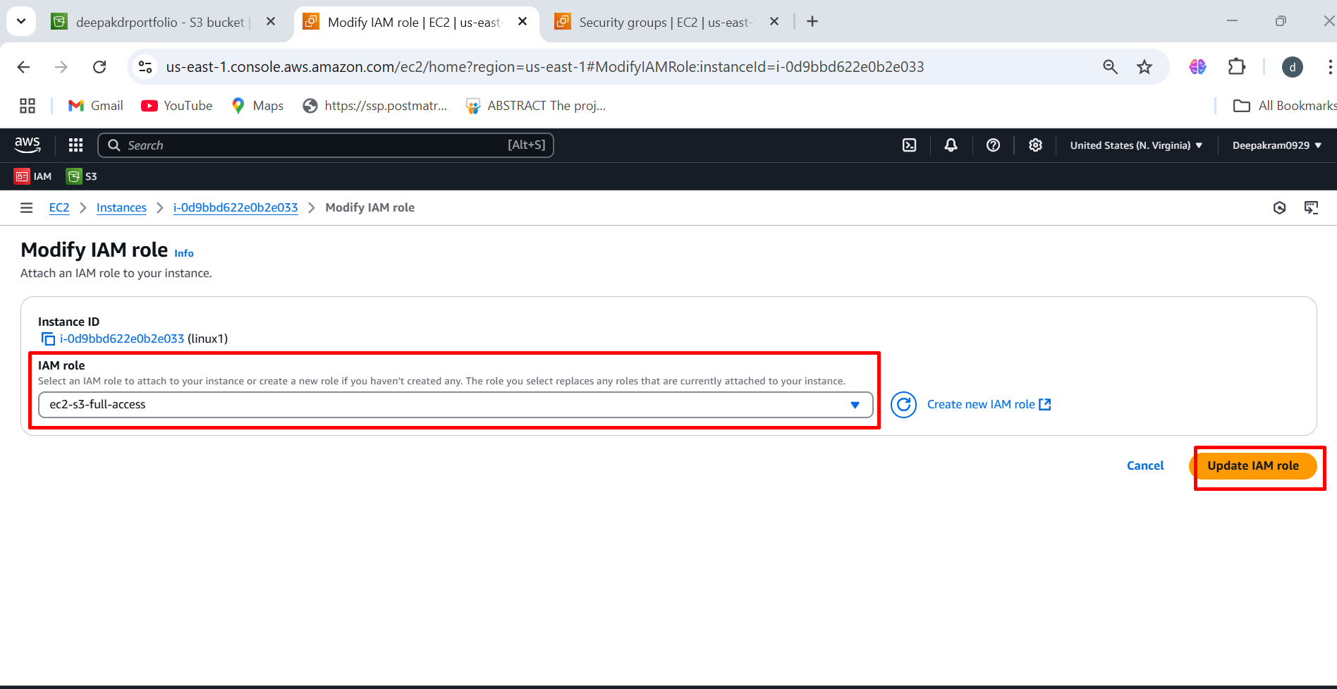

1. Select the instance 🡪 connect to the ec2 console

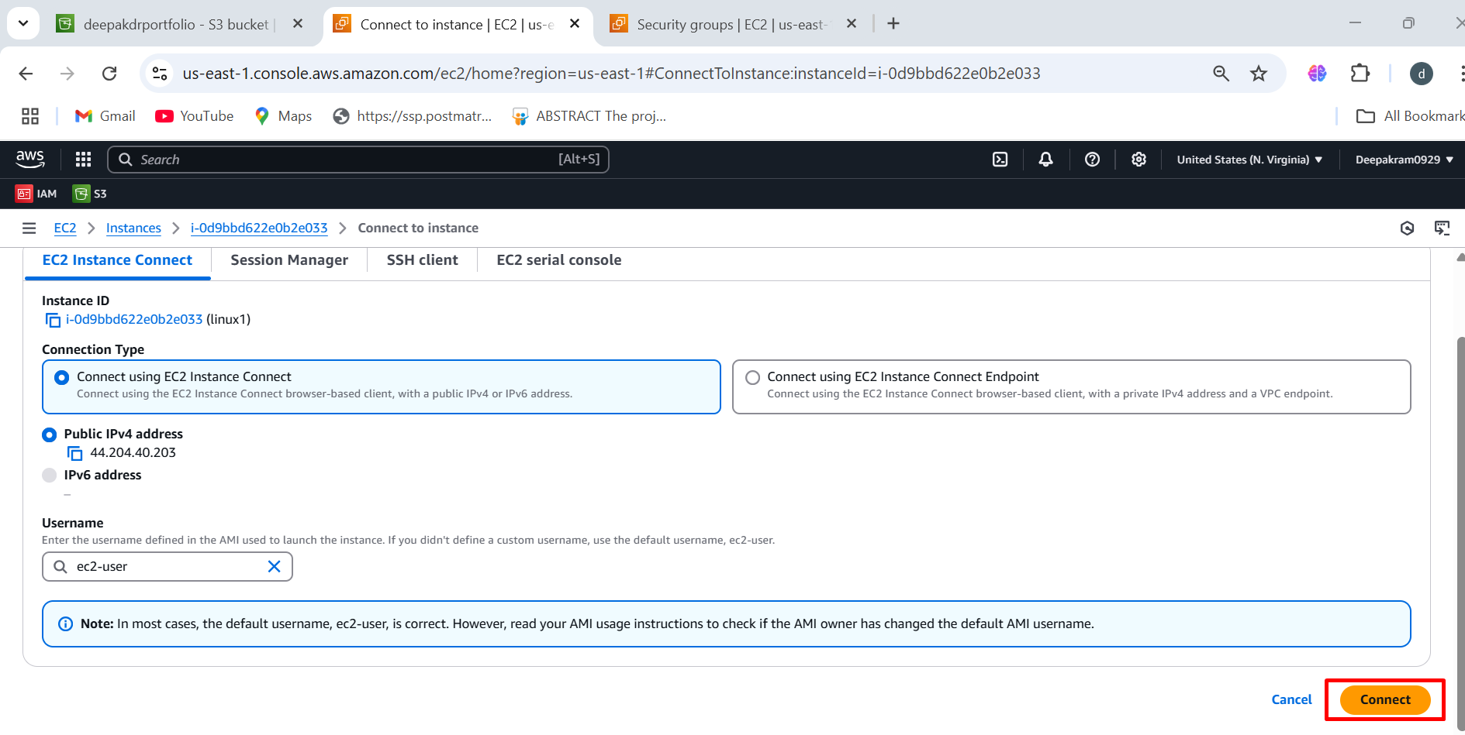

1. Install httpd to host website 🡪 yum install httpd -y

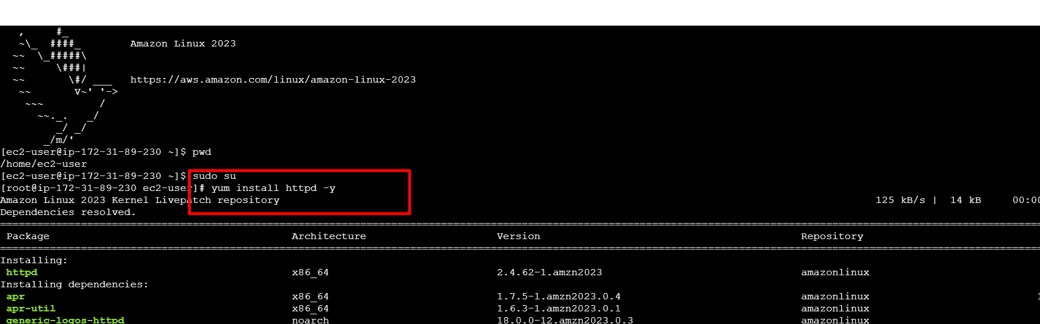

1. After the installing check the status of the httpd

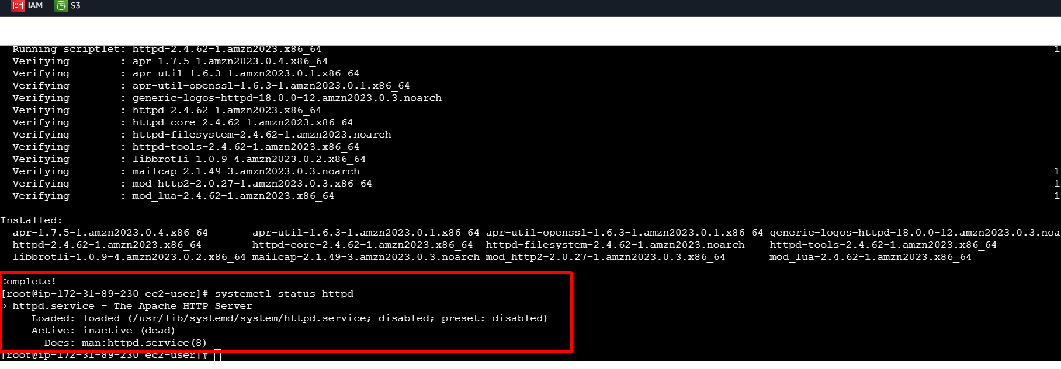

1. After enable the httpd to autostart 🡪 systemctl enable httpd

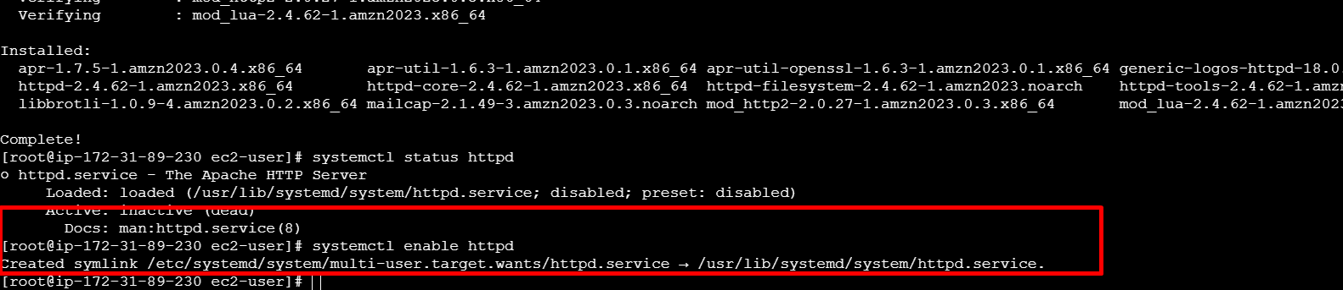

1. Then start the httpd and check the status 🡪 systemctl start httpd

systemctl status httpd

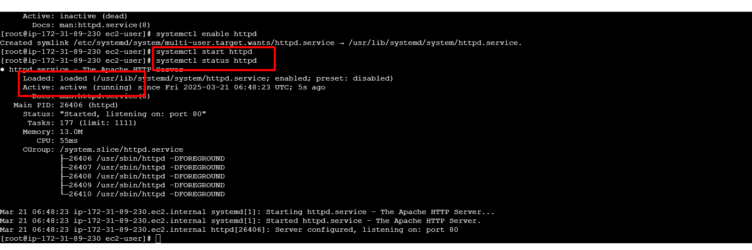

1. List the location of html

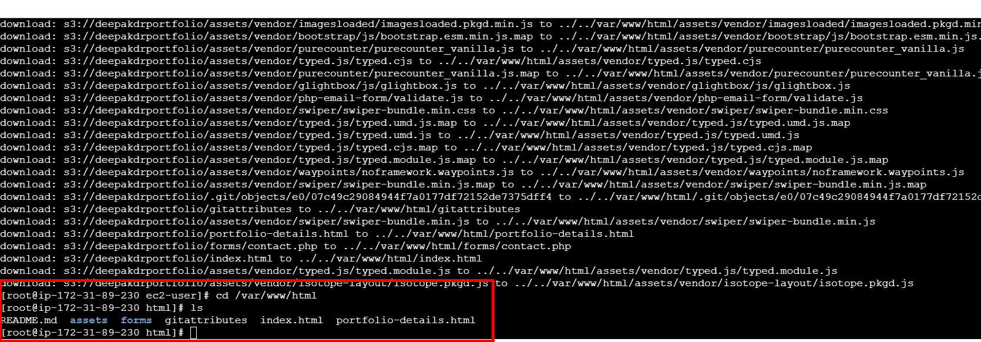

1. Paste the public IP address to see the output of website

